Extra practice
- In the following words some letters are missing. Do you know which? If you don’t, the letters in the cloud might help you.
- P P - P S H P
O
S
C
S
- H E L - E D E D L B E
U
H
U
- O T L E
L
W
U
S
- S O C A E
S
A
T
T
- M L T I H A N E L
I
O
N
G
T
- U E R S O R E
P
F
- A S O C A E
- Fill in the gaps first and then find the words in the word snake below. There are more words in the snake than you need.
1 In the city traffic is and pollution levels are high.
2 The number of at the end of the road is
declining, and the numbers of hypermarkets is increasing.
3 In some cities consumers to new malls as soon as they open.
4 Many people don’t want to buy clothes anymore that were produced in a
in India or Bangladesh.
5 If stores sell their products online, they don’t have everything on their
anymore.
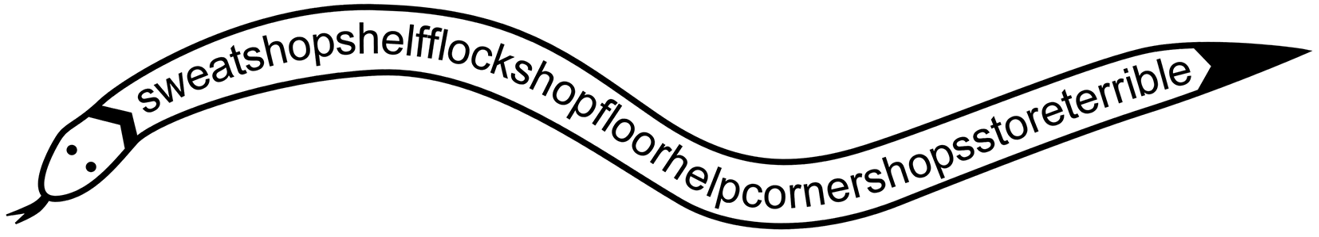
- Find a word from the same word family.
1 noun: appearance → verb:
2 noun: failure → verb:
3 noun: rent → verb:
4 noun: success → adjective:
5 noun: conviction → verb:
6 noun: possibility → adjective:

Oplossingen

1
- pop-up shop
- shelf-edged label
- outlet
- showcase
- multichannel
- superstore
- associate

2
- terrible
- corner shops
- flock
- sweatshop
- shop floor

3
- to appear
- to fail
- to rent
- successful
- to convince
- (im)possible

