Unit 1, Exercise 5
With a partner, match the sentences and the pictures and put them in the correct order.

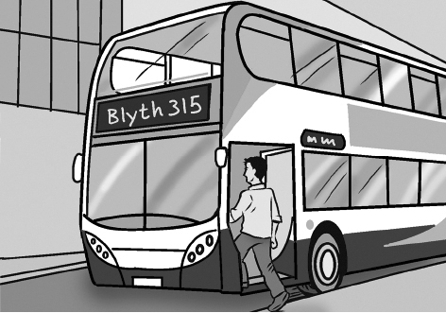  1 |  | 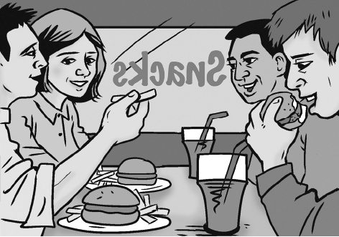  2 |  | 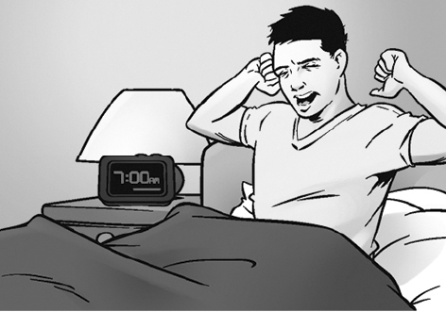  3
  4 |  | 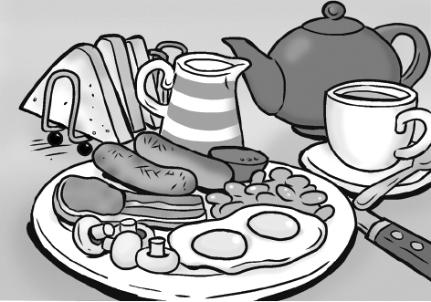  5 |  | 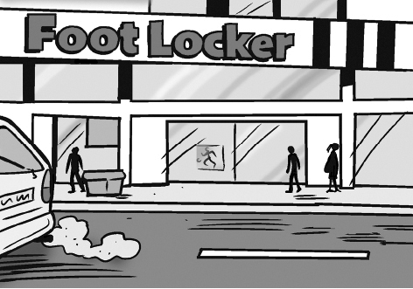  6
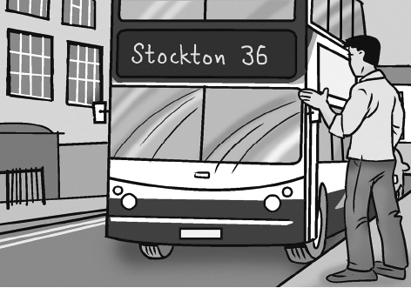  7 |  | 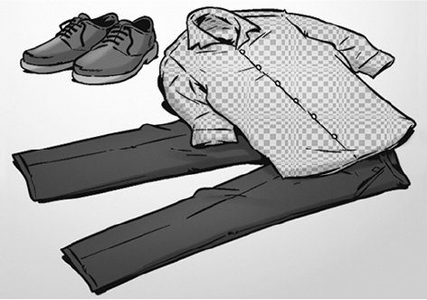  8 |  |   9

a At 7.30 he has a full English breakfast.


b He serves customers from 9 a.m. to lunchtime.


c He arrives at work at 8.30 a.m.


d He takes the bus home at six o’clock.


e He gets dressed and goes to the kitchen.


f The alarm clock rings at seven o’clock and Jamie gets up.


g He has a shower and goes back to his bedroom.


h He and his colleagues have a hamburger and a coke in a snack bar at 12.30 p.m.


i He leaves the house at eight o’clock and takes the bus to work.
Bron afbeeldingen: Oxford Designers & Illustrators
Oplossingen
f 3, g 9, e 8, a 5, i 1, c 6, b 4, h 2, d 7

