Giving directions
- Find the missing verbs.
- down Parkstraat.
- straight ahead.
- the first exit from the roundabout.
- over Nieuwstraat.
- left into Zuidweg.
- Three tourists are standing at the station. They’re asking for directions. Read the directions below and find out where each tourist wants to go.
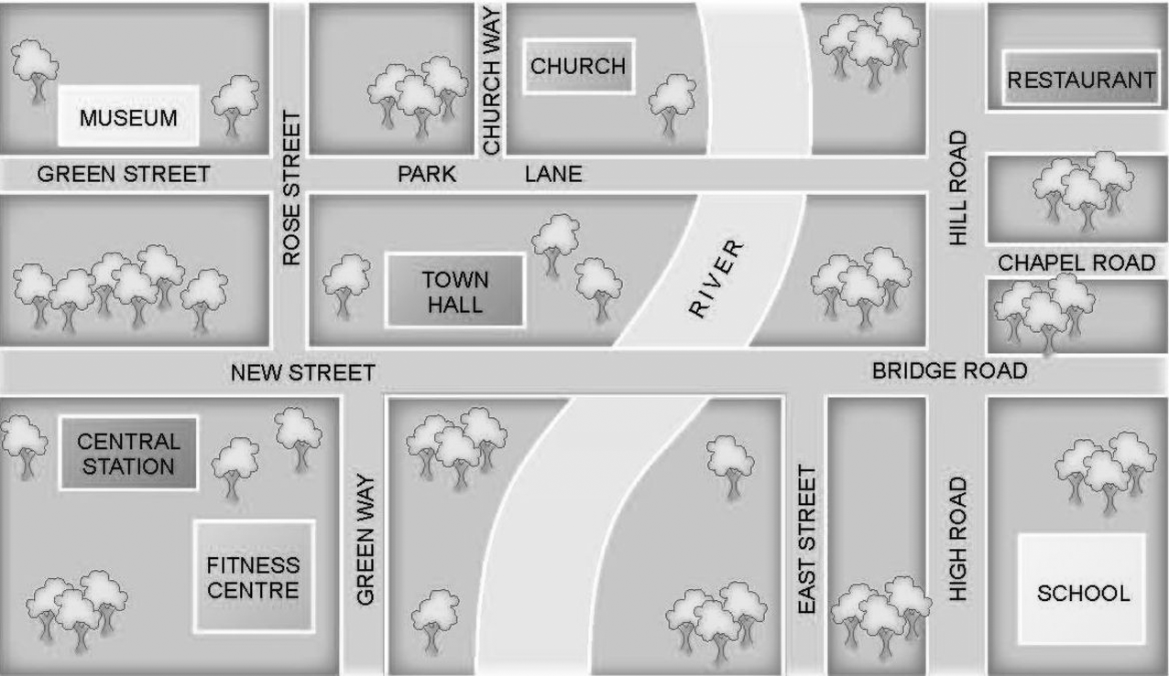

- Turn right and walk along New Street past Rose Street on your left. Go past East Street and turn right
into High Road. Go down High Road. The is on your left.
- Walk along New Street. The first street on your left is Rose Street. Turn left there. Walk along Rose
Street until you get to the crossroads. Turn right into Park Lane. Take the first street on the left and the
is on your right.
- Walk along New Street. Keep walking until you cross the river. The next street on your left is Hill Road.
Turn left there. Continue past Chapel Road and Park Lane. The is on
your right.
Bron afbeelding: Oxford Designers & Illustrators
- You’re at school. A new girl asks you how to get to the fitness centre.

- You’re on East Street. A tourist asks you where the museum is.

Oplossingen

1
- Walk
- Go/Walk
- Take
- Cross
- Turn

2
- school
- church
- restaurant

3
Voorbeeldoplossing:
Come out of the school onto High Road and turn right. Walk along the street and turn left into Bridge Road. Walk straight ahead and cross the river. Green Way is on your left. Turn left and you can see the fitness centre on your right.

4
Voorbeeldoplossing:
Walk along East Street. Turn left onto New Street/Bridge Road. Walk straight ahead and cross the river. The next street on your right is Rose Street. Walk down Rose Street and take the first left onto Green Street. The museum is on your right.

