Food vocabulary
- The animal and its meat
1 | 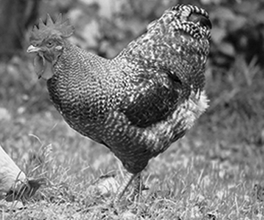 | Name of the animal:  Its meat is called
2 | 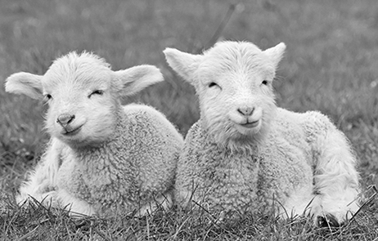 | Name of the animal:  Its meat is called
3 | 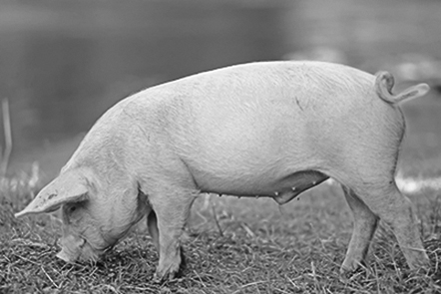 | Name of the animal:  Its meat is called
4 | 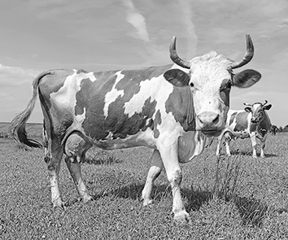 | Name of the animal:  Its meat is called

Bronnen: Shutterstock / 1 Tanor; 2 nbiebach; 3 Baciu; 4 smereka

- Complete the crossword using the pictures below.
1 |  |  |  |  |  |  | 2 |  |  | 3
 |  |  |  |  |  |  |  |  | 4 |  |  | 5
6
7
 |  |  |  | 8 |  |  |  |  |  | 9
 |  |  | 10
 |  |  |  |  | 11
 | 12
 |  |  |  |  |  |  | 13
 |  |  |  |  |  |  | 14
Across:
Bronnen: Shutterstock / 1 Nattika; 2 Vasily Menshov; 3 Dmitriy Krasko; 4 Maks Narodenko; 5 Vasily Menshov; 6 across foodonwhite;
6 down monticello; 7 Valentyn Volkov; 8 Jiri Miklo; 9 Evan Lorne; 10 tencheesiong; 11 across Olinchuk; 11 down _LeS_;
12 across Vasily Menshov; 12 down Kyselova Inna; 13 Amero; 14 Sergiy Kuzmin
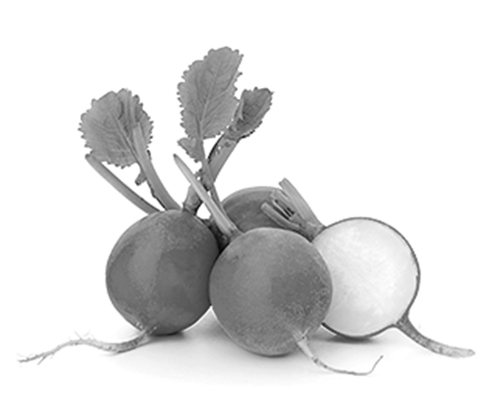  1  4  6  7  8 | 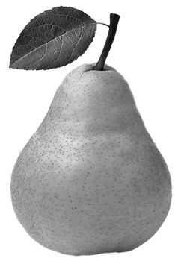 |  | 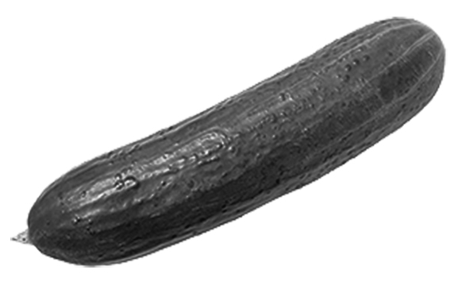 |  | 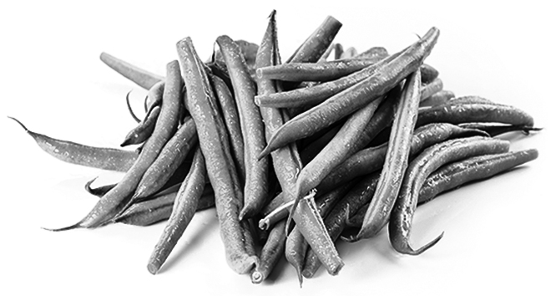 |  | 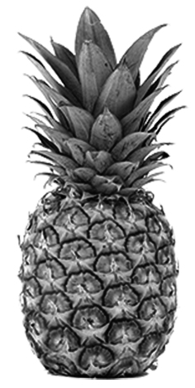
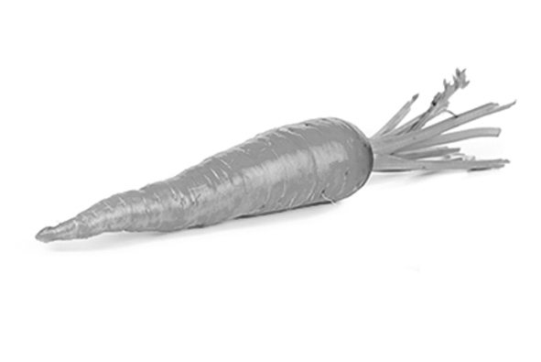  14  13  12  11 |  | 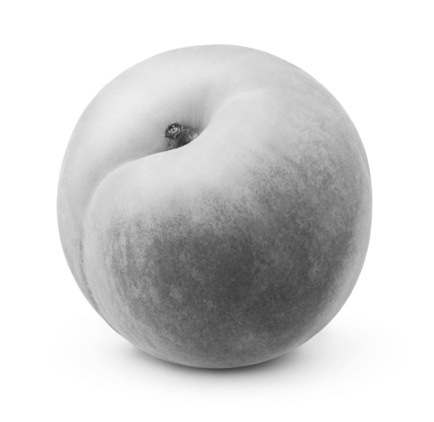 |  | 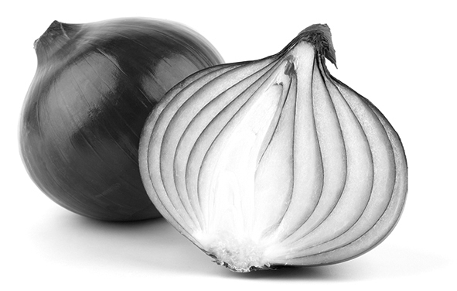 |  | 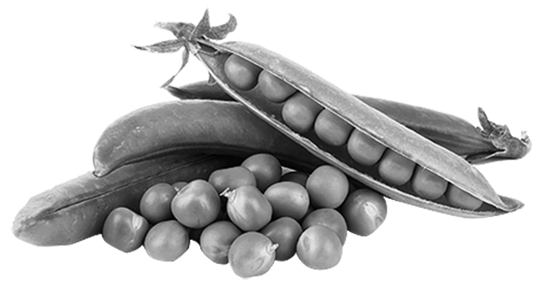
Down:
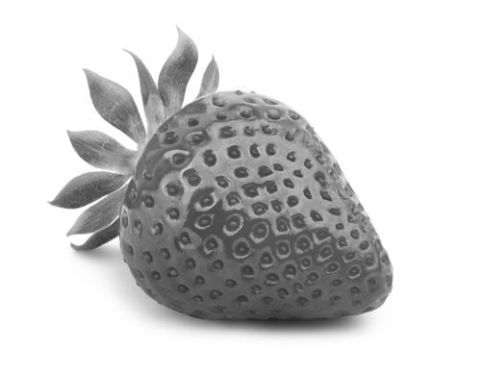  2  3  5  6 | 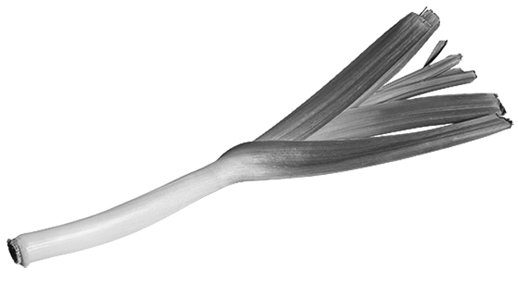 | 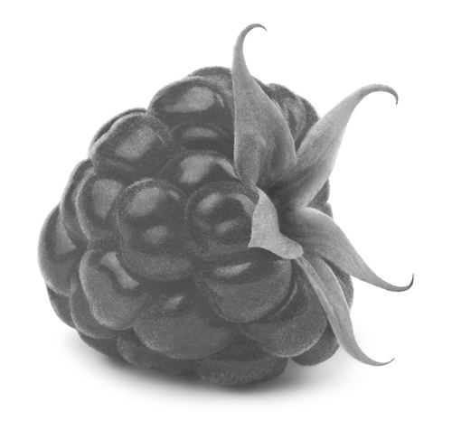 | 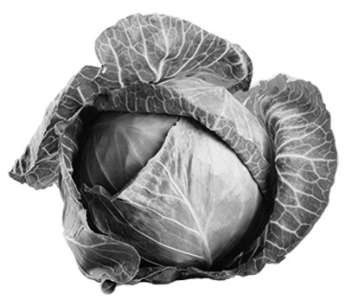
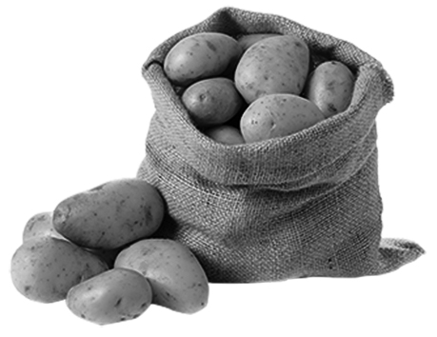  9  10  11  12 | 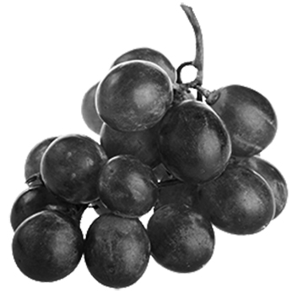 | 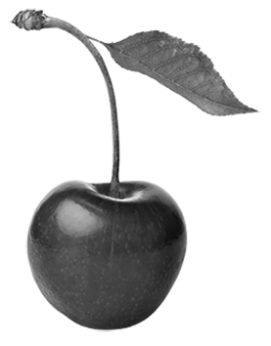 | 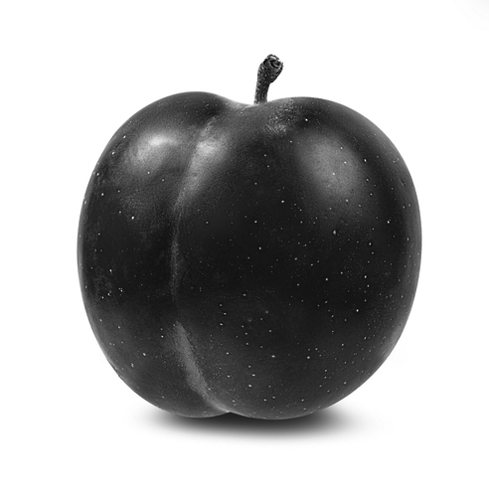  Oxford Designers & Illustrators
Oplossingen

1
- chicken / chicken
- lamb / lamb
- pig / pork
- cow / beef

2
R | A | D | I | S | H | E | S |  |  | L
 |  |  |  |  |  |  | T |  | P | E | A | R
C | U | C | U | M | B | E | R |  |  | E |  | A
A |  |  |  |  |  |  | A |  |  | K |  | S
B | E | A | N | S |  |  | W |  |  |  |  | P
B |  |  |  |  |  |  | B |  |  |  |  | B
A |  |  |  | P | I | N | E | A | P | P | L | E
G |  |  | G |  |  |  | R |  |  | O |  | R
E |  |  | R |  | C | A | R | R | O | T |  | R
 | P | E | A | C | H |  | Y |  |  | A |  | Y
 | L |  | P |  | E |  |  |  |  | T
 | U |  | E |  | R |  | O | N | I | O | N
 | M |  | S |  | R |  |  |  |  | E
 |  |  |  |  | Y |  | P | E | A | S

