Organic produce – comparatives and superlatives
Imagine you are working in a shop selling organic products. Use the seasonal calendar to explain to an English-speaking customer when organic fruits and vegetables are most and least expensive. Write at least 10 sentences like this:
Strawberries are cheapest in … but most expensive in …
Grapes are less expensive in …

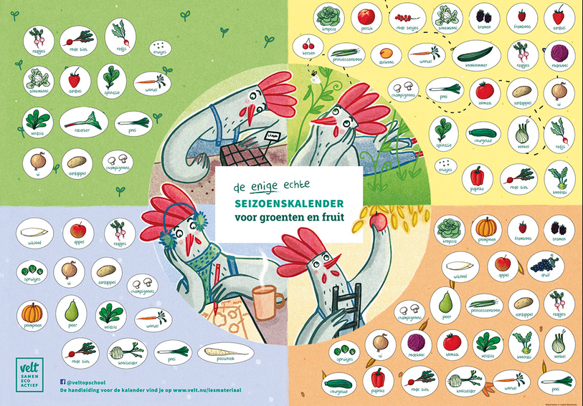
Bron: velt.nu

Voorbeeldoplossing
Spinach is cheapest in spring and summer and most expensive in autumn and winter.
Raspberries are always expensive but they are less expensive in summer.
Apricots are cheaper from June to October.
Cherries are more expensive in winter.
Cucumbers are cheapest in summer.

