Clothing vocabulary
- What are they called? Add the English words to the pictures.
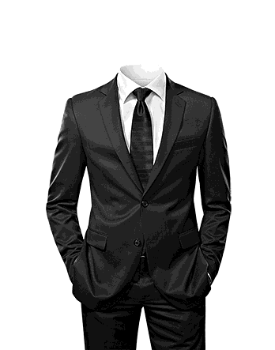 | 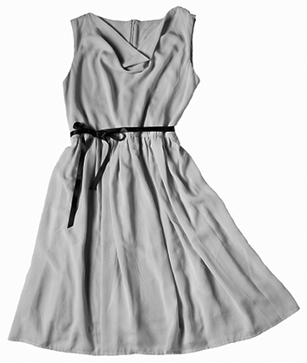 |  | 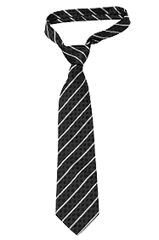 | 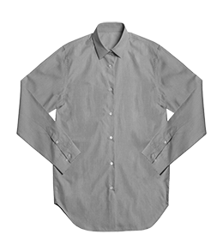 | 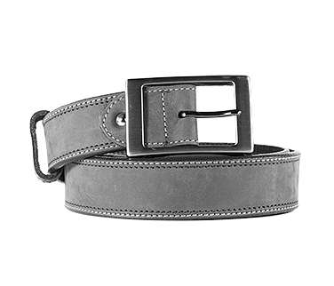 |  | 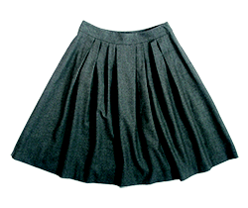 |  | 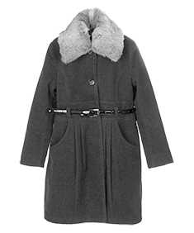 | 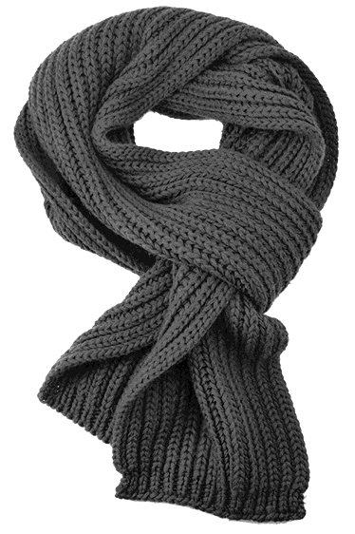
1  5 |  | 2  6 |  |  |  | 3  7 |  | 4  8
- A short dress code for a job interview at a bank. Complete the text with words from the box.
blouse • condition • expensive • features • footwear • impressive •
price tags • professional • shave • shirt • tights • wear
• Make sure no 1 are hanging out from your clothes.
• As a future banker you should look 2 – not trendy.
• Wear neutral tones, nothing loud or shiny. Darker tones are more 3
• Your clothes needn’t be 4 but they must be in perfect
5.
• Men and Women: Wear a good-quality 6 or
7 in a colour that suits your skin.
• Don’t wear sneakers. Your 8 must fit the occasion.
• Women: If you wear a skirt, choose light-coloured 9.
Dark ones are evening
10.
• Men: 11 well before you go to the interview.
• Women: Wear only a little make-up to bring out your best 12.
Bronnen: Shutterstock / 1 Sfio Cracho; 2 monika3steps;
3 terekhov igor; 4 OZaiachin; 5 pattarastock; 6 Karkas; 7 Polryaz; 8 Adisa

Oplossingen

1
- suit
- dress
- tie
- shirt
- belt
- skirt
- coat
- scarf

2
- price tags
- professional
- impressive
- expensive
- condition
- shirt
- blouse
- footwear
- tights
- wear
- shave
- features

