Unit 6, Exercise 7C
Work with a partner to do a role-play in a clothing shop.

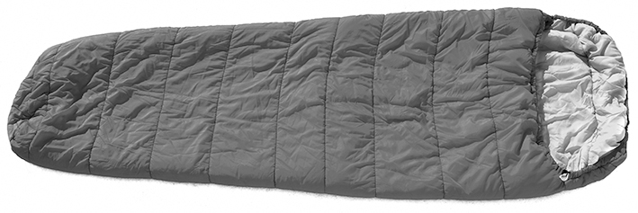
Partner A: Verkoopmedewerk(st)er
Uitvoering
Materiaal buitenkant: Polyester
Voering:Polyester
Vulling:Microfiber
Gewicht:1,4 kg
Temperauur: tot –10°C
Prijs:€ 59,00

Je werkt op de sportafdeling van een warenhuis. Een Engelssprekende toerist is slaapzakken aan het bekijken en vraagt je om de wasvoorschriften voor slaapzak Alaska uit te leggen.

Gebruik de Care symbols chart (tekstboek p. 68) om de symbolen uit te leggen.
Geef antwoord op de andere vragen van de klant.
Improviseer de rest van het gesprek.
Bronnen: Shutterstock / 1 Mark Herreid; 2 Strejman



Partner B: English-speaking tourist
You are on a camping holiday in the Netherlands and need a new sleeping bag. You go to the sports department of a big department store and find an Alaska sleeping bag but are not sure what the following symbols mean.

Ask the assistant to explain the symbols.
Ask about the materials the sleeping bag is made of, the weight, the coldest outdoor temperature possible and the price.
Invent further questions.

Voorbeeldoplossing
A Hello. How can I help you?
B Hello. I would like to buy this sleeping bag but I don’t understand the symbols on the label.
Could you explain them to me, please?
A Of course, sir. This first one means that the sleeping bag should be hand washed. The next one says
that you shouldn’t bleach the product and this one means do not iron. The square with a circle inside means that you can’t tumble dry the sleeping bag and the last symbol means it can’t be dry cleaned.
B Oh right, thank you. Can I ask what the sleeping bag is made of?
A Of course, sir. The outer material and the lining are made of polyester, and the stuffing is made
of microfiber.
B And could you tell me how heavy the sleeping bag is?
A It’s 1.4 kg, sir. Can I help you with anything else?
B Yes, please. Could you tell me how much it costs, and also, what is the coldest outdoor temperature possible, please?
A No problem. You can use the sleeping bag at up to -10 degrees, and it costs €59.
B That’s a great price. I’m not sure I like the colour, though. Is it available in other colours?
A Yes, sir. There’s this orange but you can also buy it in black, dark green and navy blue.
B My tent is dark green so I think I’ll take that colour. I’ve got one last question.
Is it possible to pay by credit card?
A Of course, sir. If you’re happy with the sleeping bag, I’ll take you to the cash desk.
B Great, thanks.

