Vocabulary and footwear
- Find the opposite of the phrases below.
1 outdoor wear → wear
2 casual clothes → clothes
3 a tight fit → a fit
4 a narrow collar → a collar
5 modern trousers → trousers
6 at a low temperature → at a temperature
- Find the nouns of these adjectives and verbs.
1 wide →
2 long →
3 to receive →
5 to deliver →
6 to sell → be on
- Label the footwear.
Bronnen: Shutterstock / 1 Photobac; 2 gorbelabda; 3 szefei;
4 Edward Westmacott; 5 lablonskyi Mykola; 6 Nattika

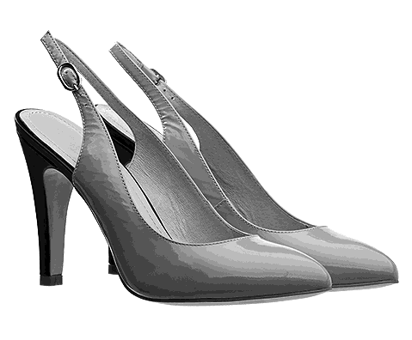 | 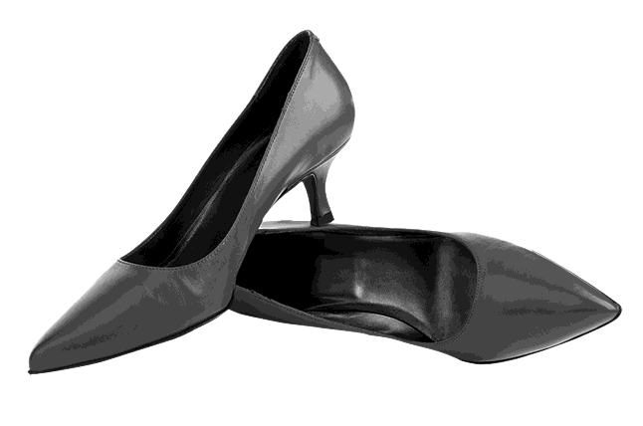 | 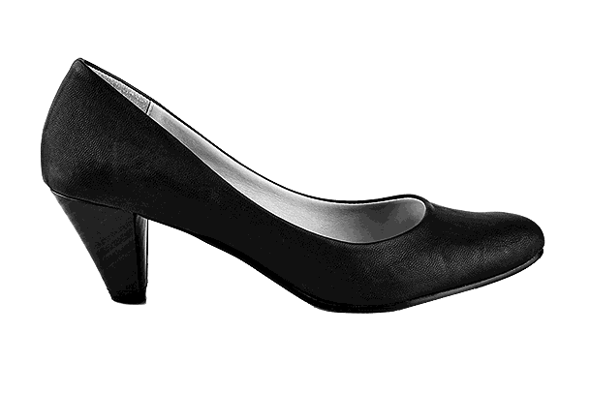
1 | 2 | 3
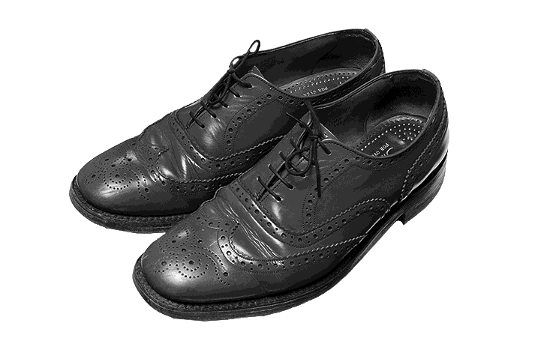 | 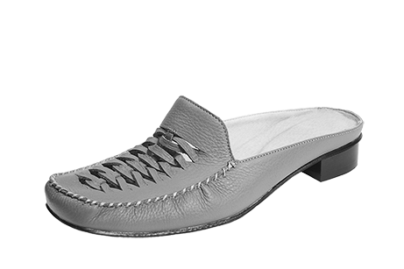 | 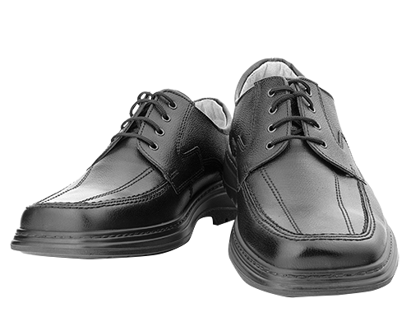
4 | 5 | 6
Oplossingen

1
- indoor
- formal
- loose
- wide
- old-fashioned
- high

2
- width
- length
- receipt/reception
- delivery
- sale

3
- slingbacks
- kitten heels
- court shoes / pumps
- brogues
- mules
- lace-ups

